**Feather Stitch**

This stitch is little more advanced than the two previous that we have tackled. It is a useful stitch as it can add more to your project and work in conjunction with the stem stitch. Many quilters use this stitch and can be found in many American quilt books especially on crazy patchwork

After reading many embroidery books it is suggested that for your first attempt you mark your fabric with four parallel guidelines in tailor’s chalk or disappearing pen.

To start bringing your thread to the front on the first line. Holding the thread down with your left thumb, insert your needle on the third line level where the thread emerges. You then need to work down and diagonally so that you come up on the second line. Keep the thread under the needle. This makes your first stitch.

1. 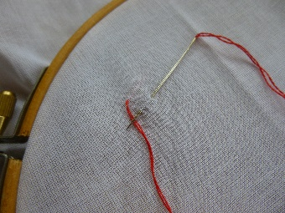 2. 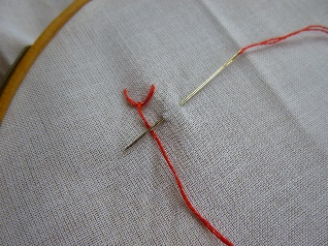 3. 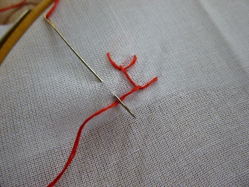

For the next stitch insert your needle on the fourth line and level to where your needle emerged on the last stitch. Come up again on the third line. Repeating the previous stitch

4. 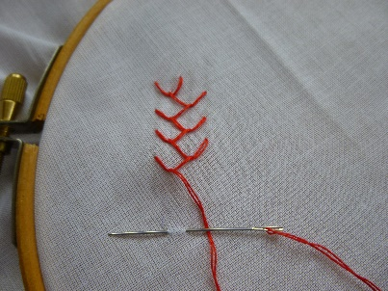

Keep repeating the same thing working back and forward across the lines.

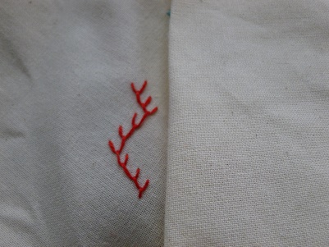To finish make a small stitch over this last loop.

