Blanket Stitch

This stitch is one used for many craft projects. It is used to sew the edge of thick or heavy fabric especially those that do not fray such as felt. Sewing hand appliqué to items is often seen.
After threading the needle with a strand of embroidery floss and then make a knot on one end.
Take your piece of fabric and hold it tight in front of you. Draw two parallel lines. These will be your guide lines. Now insert the needle from the bottom side to the top at the edge of the fabric at the left.
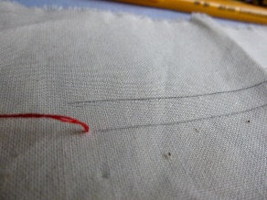 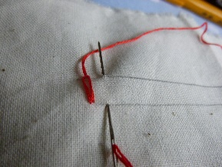 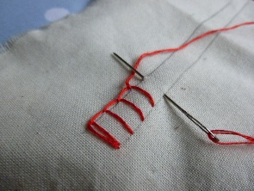
Now insert the needle again from the drawn line and take the needle out at the edge of the fabric, directly opposite to the location where the needle was inserted.
As you draw the needle out through the top edge of the fabric, make sure that the thread is under the needle.
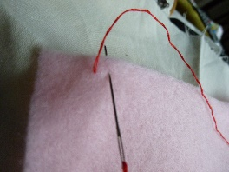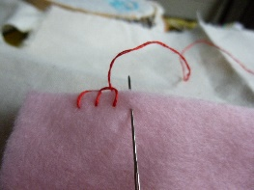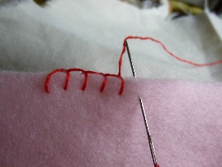
The stitch will look square and this is what you want.
Again insert the needle at the line at equal distance and take it out parallel to it at the edge.
Place the thread under the needle and draw out the needle slowly, making sure that the stitch is secure.
Repeat steps, making sure that the height as well as the spacing of the stitch is maintained.
When you finish, insert the needle through the back of the stitch and secure with a knot.
Blanket stitch is one of the most simple and easiest stitch to master. It comes in very useful for making appliqués and for embroidery.
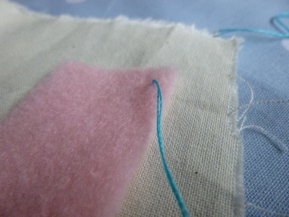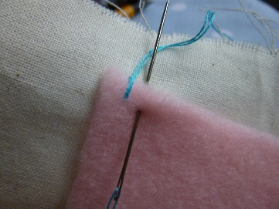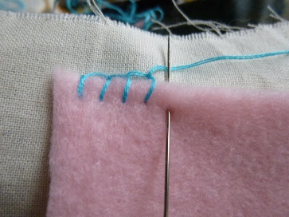
The stitch can be used as an edging, to attach motifs, buttonholes and decorative finish to many projects
The photos show the very basic structure of the stitch ready for you to experiment and create your own unique variations.

