Chain Stitch.
The basic chain stitch is easy to complete and very popular. It gives a texture to your work, and can be completed relatively quickly. It gives a chain like appearance. Another use is to form petals to create a daisy.
To start the stitch work you may like to lightly draw your lines onto your fabric
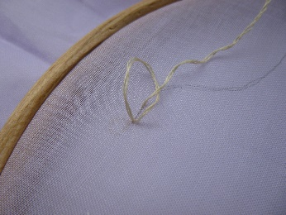
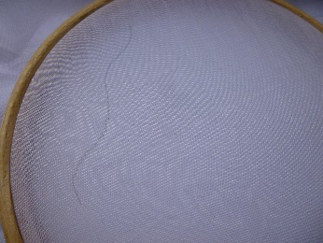
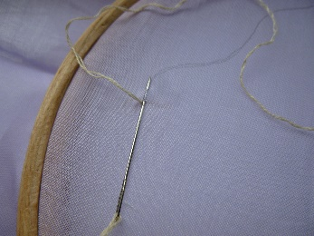

Bring the thread out to the front of the fabric (A). Put the needle back in at point A and bring it out again to the length required for the link. (B), then …….. Take the thread around the needle to form a loop.
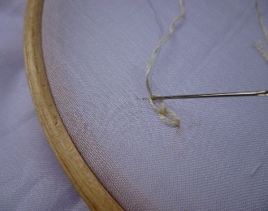
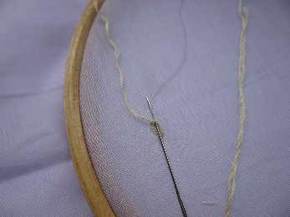
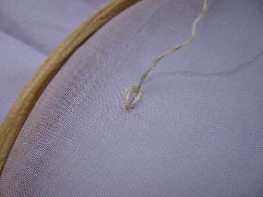

Pull the needle through to form the loop, although be careful not to pull too tight and gather the fabric This is the first part of the chain.
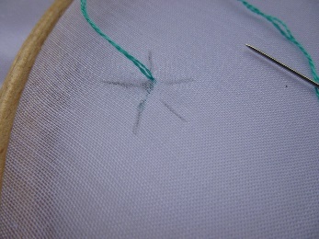
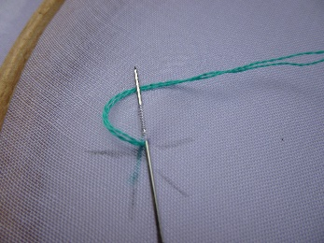
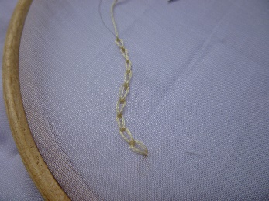

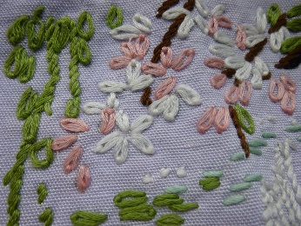
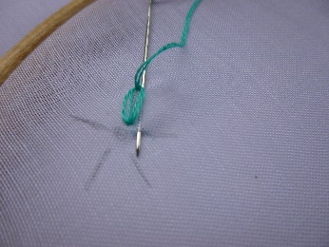
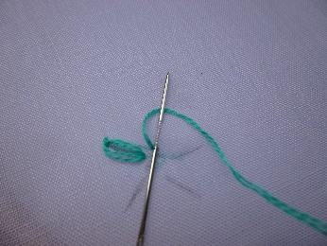
To complete the daisy stitch otherwise known as lazy daisy. You will need to work each chain stitch as a standalone stitch.

Start by drawing the circle of lines as shown. Then work the chain as previously but instead of working forward you come back on yourself. Coming out at the base of the next petal ready to form the next chain.
The many embroidery books and web sites provide ways to use these stitches and the different adaption that have be made over the years. Good luck exploring now you know the basic stitch.

