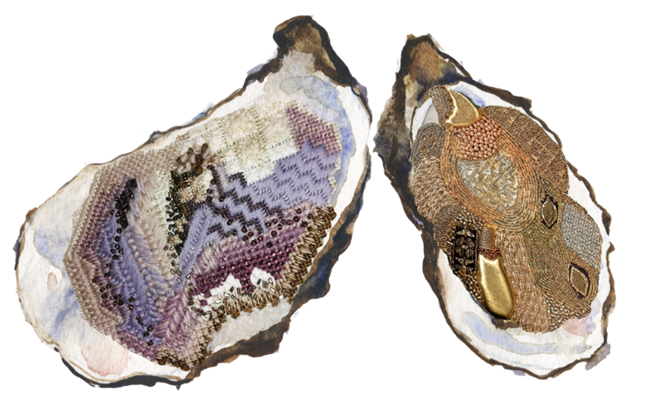
ENTRY CATEGORIES FOR EASTERN REGION MEMBERS:
- Adult – Age 21+
- Individual Junior/Student - Age 12-21
- Individual Junior – Under 12
- Group* – Maximum of 4 members, any age
Entries in any category may be hanging or table standing, 2D or 3D.
Maximum size 50x50x50cm including frames etc

CRITERIA FOR ENTRIES:
- Please read additional information on registration sheet.
- A competition entry form must be completed and submitted by 30 April 2020
- Entries must be delivered to the venue FIRSTSITE, Lewis Gardens, Colchester, CO1 1UE by 10.15am on the day
- Entries must be labelled with the E.G. member’s name, membership number and telephone number.
- Entries should be brought ready for hanging / placement in their own labelled packaging and must be
collected by 4pm on the day.
- Only one entry per member or group
- The competition will be judged by the Speakers, with an additional award being given to the winner of
the 'Public's Choice' vote.
- Entries must not be removed from the display area without consent from competition administrators
*ADDITIONAL INFORMATION FOR GROUPS:
This category is intended for E.G. Members who have not entered an E.G. embroidery competition before.
The concept is for each branch to mentor a maximum of four members in a group that contains a range of ages (i.e. YETS / JETS / ADULTS) through the competition process. This will include design, design to stitch, stitch to finished item, competition registration, results of competition, review and evaluation of experience, (i.e. after the event).

For further information or queries relating to the competition, please email e.g.colchester@gmail.com

COMPETITION ENTRY FORM
Please fill out the right hand column with your information. Put an ‘X’ in only one row for ‘Category of Entry’ to indicate which you are entering.
Member/Group Name
E.G. Membership Number(s)
E.G. Branch
Your Contact Details
(phone, email or postal address)
Category of Entry - Adult – Age 21+
Category of Entry - Individual Junior/Student - Age 12-21
Category of Entry - Individual Junior – Under 12
Category of Entry - Group – Max. 4 members, any age
Estimated Value of Materials Used (for insurance purposes)

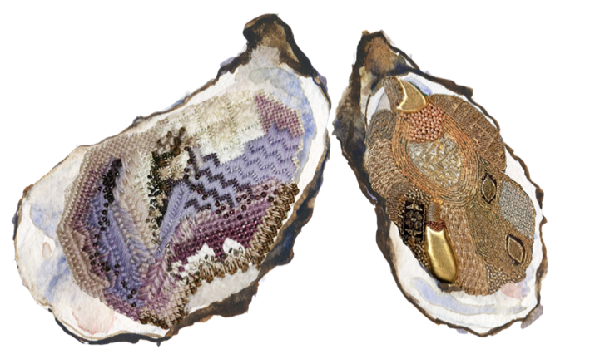
Submitting Your Registration:
You may submit your entry form via e-mail to e.g.colchester@gmail.com
or by post to Mrs Teresa Tokeley, 48 Old Ferry Road, Wivenhoe, Colchester, Essex, CO7 9SW
Entries which have not been pre-registered may be accepted on the day if they meet the entry criteria. An entry form will still need to be completed.
Data Protection:

Your personal data will be held and used for administering your competition entry/entries. Data will not be shared with any other source and will be safely removed after the competition event, subject to the return of all entries from the Competition Administrators.

